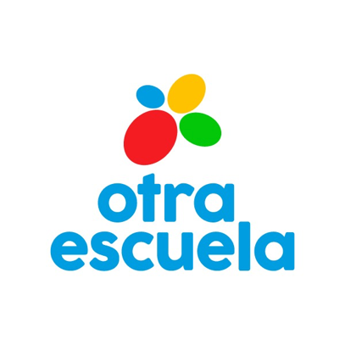

Play Your Heart Out Application Form
Deadline: Thursday 13th March 2023
Training course 7th-13th May 2023 (travel inc.)
Garaldea Ecofeminista, Chinchón (Madrid), Spain

SENDING ORGANIZATION:

FIRST NAME:

SURNAME:

GENDER: □ Male □ Female □ __________ (specify as desired)

DATE OF BIRTH:

PLACE OF BIRTH (town, country):

RESIDENCE ADDRESS (street, town, country):

TELEPHONE:

E-MAIL:

EMERGENCY CONTACT:

Name: Surname: Telephone:

INDIVIDUAL/SUPPORT NEEDS (OR PHYSICAL/MENTAL HEALTH REMARKS):

THIS IS A REQUIRED QUESTION

COVID-19 VACCINE and EU DIGITAL COVID CERTIFICATION:
□ 2° dose. Please indicate the date of your 2° dose ______________________
□ 3° dose booster. Please indicate the date of your 3° dose ____________________
□ Recovered from Covid-19 (only valid if you have recovered from less than 180 days). Please indicate the date shown in your EU DIGITAL COVID CERTIFICATION ____________________
For more information regarding Covid-19 and travel, please check the Spanish Ministry of Health webpage.

THIS IS A REQUIRED QUESTION

CITY OF DEPARTURE
Please, specify the city, and the nearest airport, from where you will start your travel to join the project:
____________________________________________________________________

CITY OF RETURN (only if different from the city of departure)
Please, specify the city, and the nearest airport, where you will return after the project:
____________________________________________________________________

THIS IS A REQUIRED QUESTION

DIETARY NEEDS: (intolerances, restrictions, allergies) please specify
□ No extra requests
□ Vegan
□ Vegetarian
□ Lactose free
□ Gluten free
□ No pork
□ No fish
□ No alcohol
Other:
THIS IS A REQUIRED QUESTION

PAST EXPERIENCES/PERSONAL PROFILE RELEVANT TO THE PROJECT:

MOTIVATION TO TAKE PART IN THIS PROJECT:

EXPECTATIONS TO TAKE FROM THE PROJECT:

VISA DETAILS IF NEEDED:
*if necessary attach copy of passport

ADDITIONAL COMMENTS:

