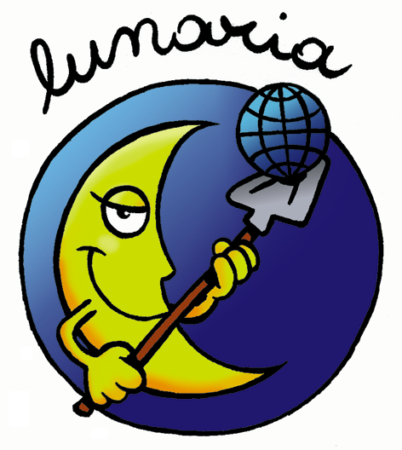


ERASMUS+ PROGRAMME
Key action 1 - Learning Mobility of Individuals

HURRICANE
HUman Rights' awareness Raising by Improving Creative Actions and Non formal Education
VIRTUAL YOUTH EXCHANGE 1
04 – 13 June 2021 (10 days)
Please return this form, within the 20/05/2021
to: scambi@lunaria.org

I CONFIRM THAT I HAVE READ LUNARIA PRIVACY POLICY □
THIS IS A REQUIRED QUESTION

SENDING ORGANIZATION:

FIRST NAME:

SURNAME:

GENDER: □ Male □ Female □ Other

DATE OF BIRTH:

PLACE OF BIRTH (town, country):

RESIDENCE ADDRESS (street, town, country):

TELEPHONE:

E-MAIL:

PAST EXPERIENCES:

WHAT IS YOUR MOTIVATION TO TAKE PART IN THIS PROJECT?:

WHAT ARE YOUR EXPECTATIONS TOWARDS THE VIRTUAL YOUTH EXCHANGE?

