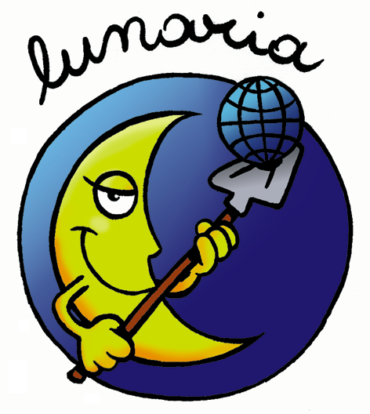


ERASMUS+ PROGRAMME
Key action 1 - Learning Mobility of Individuals

HURRICANE
HUman Rights' awareness Raising by Improving
Creative Actions and Non formal Education

TRAINING COURSE
10th– 16th October 2019 (7 days)
(09thof October 2019: arrival day - 17thof October 2019: departure day)
Casa-Laboratorio Il Cerquosino, Morrano, Orvieto (TR), ITALY

Please return this form, within the 16/08/2019
to: scambi@lunaria.org

I CONFIRM THAT I HAVE READ LUNARIA PRIVACY POLICY □
THIS IS A REQUIRED QUESTION

SENDING ORGANIZATION:

FIRST NAME:

SURNAME:

GENDER: □ Male □ Female □ Other

DATE OF BIRTH:

PLACE OF BIRTH (town, country):

RESIDENCE ADDRESS (street, town, country):

TELEPHONE:

E-MAIL:

EMERGENCY CONTACT:

Name: Surname: Telephone:

SPECIAL NEEDS (OR HEALTH REMARKS):

THIS IS A REQUIRED QUESTION

DIETARY NEEDS: (intolerances, restrictions, allergies) please specify
□ No extra requests
□ Vegan
□ Vegetarian
□ Lactose free
□ Gluten free
□ No pork
□ No fish
□ No alcohol
Other:
THIS IS A REQUIRED QUESTION

PAST EXPERIENCES:

WHAT IS YOUR MOTIVATION TO TAKE PART IN THIS PROJECT?:

WHAT ARE YOUR EXPECTATIONS OF THE TRAINING?:

IF VISA IS NEEDED (attach also a copy of the passport):

N° of passport:

Date of issue:

Date of expiry:

Place of issue:

Date of birth:

Place of birth:

Nationality:

