Youth Exchange “Disposable Things”
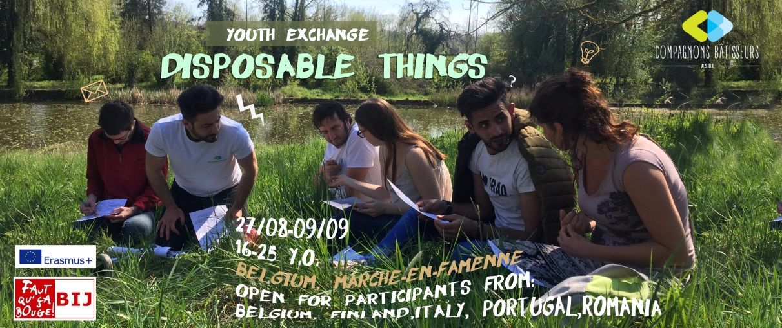

Who? 26 participants (animators and supporting people included) from 16 to 25 years coming from Belgium, Italy, Finland, Romania and Portugal. The group will be social and culturally diverse.

When? From Tuesday 27 August to Monday 9 September 2019.

Where? In Marche-en-Famenne, a semi-rural lively town, located in the French-speaking part of Belgium.

  - Activities:
« Disposable Things » has the objective to allow anyone to invest themselves in a project which will lead them to reflect about the "consumption" of smartphones and social networks.

The participants will have the possibility:

- to express their points of view regarding the responsible and conscious use of communication tools, its numerous drifts and opportunities;
- to develop a critical perspective toward our virtual behaviors;
- to open their minds and develop their self-confidence through manual and creative workshops;
- to analyze the different medias/social networks: differences, codes, behaviors, their manipulation;
- to develop a first approach to media education: codes, rules, cultural differences;
- to participate in photography workshops based on the importance of "the image" in a "connected" visual society;
- to spend 24h totally disconnected and in full nature;
- to carry out a media campaign on the responsible consumption of social networks and smartphones;
- to debate on the basis of presentations/documentaries highlighting the excesses of the consumption of social networks and the media;
- to share their adventure with the local community through a public exhibition;
- to spend a great time together with young people they would not have the opportunity to meet without this exchange.

  - To do what?

By hosting “Disposable Things” we want to focus on the use of social Medias (Facebook, Twitter, Instagram …) and particularly the impact of these new technologies on our daily lives and how they affect the way we relate to the society. It comes out from a finding about the behavior of young people who participate in our projects. The connected tools are increasingly present on our activities and affect to a certain extend the project’s dynamic and the relationships between participants.

This project is built around cross-cutting questions/findings:

- “Which importance and space do the social Medias take and how our behavior are changed and influenced?” “Do we use them or do they use us?”

- We are in a society where recording an event seems more important than living it: “is it really a need?”

- Our reality is constantly filtered through the screen of a smartphone: “What else is there if we raise our eyes from the screen?”

Through the use of non-formal education and artistic methods, we hope participants will develop their critical mind and learn about how these topics are treated in different countries and in Europe in general.

The creative workshops will be led by an artist experienced in working with images through different means (photography, visual arts, photomontage, …) in order to appropriate it and use it as a communication tool.

Photo is not just a click on your smartphone!

This project is a good opportunity for people who like to valorize their sense of creativity.
This project will gather 5 groups of 5 participants and will be socially and culturally heterogeneous.

A media campaign will be carried out to raise awareness on the responsible consumption of social networks and smartphones.
A final exhibition will be organized publicly in Marche-en-Famenne.

  - Living conditions and accommodation:

The participants will be housed in the former boarding school of Marche-en-Famenne, the Saint-François complex; and will share double or triple rooms. They will have access to a kitchen, a large common room and the many green spaces around.

  - Expectations towards the participants:

By enrolling in this project, we ask you to be:

- Ready to roll up your sleeves and get actively involved in the different workshops,
- Prepared to exploit your imagination and express your creativity,
- Ready to live experiences with a group, share and question your virtual habits,
- Ready to be totally disconnected for 24h in the middle of nature,
- Ready to invest in a collective dynamic and daily life.
Date de naissance/Birthdate……………………………………. Contact d’urgence/Emergency contact
Lieu de naissance/Place of birth………..…..…………………. …………………………………………..
Nationalité/Nationality…………………………………………… ……………………………………………..
Études en cours/Occupation…………………………………... Régime spécial santé/alimentation
Langues/Languages Remarks on health/special needs
Couramment/Speak well…………………………….,……………………… ……………………………………………………………………….
Bien/Speak some…………………………….. ………………………………… ………………………………………………………………………..
Base/Basic………………………………………………….. ….………………….. ………………………………………………………………………..
Youth Exchange – “Disposable Things”
Registration form
27 august to 09 september, Marche-en-Famenne

To fill
Why do you wish to take part in this project ?

……………………………………………………………………………………..……………………………………………………………………………………………………..
……………………………………………………………………………………..……………………………………………………………………………………
……………………………………………………………………………………..……………………………………………………………………………………

Past experiences (volunteering, youth movement, group holidays…):
……….………………………………………………………………………………………………………………………………………………
……………………………………………………………………………………..……………………………………………………………………………………

Association des Compagnons Bâtisseurs asbl
9, Place du Roi Albert

6900 Marche-en-Famenne Belgique

Phone. +32 (0) 84 31 44 13
Web : www.compagnonsbatisseurs.be
To be sent to incoming@compagnonsbatisseurs.be

YOU HAVE TO READ CARREFULLY AND TO APPROVE, BY SIGNING IT. YOUR REGISTRATION FORM IS CONSIDERED AS COMPLETE ONLY IF WE RECEIVE THIS PAGE SIGNED ACCOMPANIED BY YOUR HEALTH RECORD FORM.

Date :

Signature :

Signature des parents pour les moins de 18 ans/
Parents’s or legal tutor signature if you’re below 18 yo :

Nom /Surname……………………………….…………………………………………….. M/Male F/Female
Prénom /First name…………………………………………………………... Age……………………….
Adresse de contact/contact address……………………………..……….. Tél………………….……
……………………………………………………………………………………………… GSM…………………………
Adresse email/ Email……………………………………………….….……… ID or passport number :……….

