**Mosaïc of Diversitiy**

**Youth Exchange - 02/10/2017 – 08/10/2017**

**ABOUT YOUR ARRIVAL**

**Emergency number: (Only if you have a problem on the arrival day !!!)**

CBB staff: **+32 496/27 13 09**

**Meeting point:**

**At Marche-en-Famenne on Monday 02nd October 16.30 pm.**

Depending of your route, you will arrive **either at the train station, either at the Flibco bus stop**.

Confirm us in advance you arrival time and if you wish to be picked up at the station or the bus stop.

**We will be there to welcome you.**

**How to get to the meeting point?**

From ***Brussels National Airport***, trains go to ***Brussels North*** every 20 minutes (the journey takes 15 minutes). From *Brussels North*, take the IC train with direction *Luxembourg*, get off in ***Marloie*** (about 1h30).

From *Marloie*, take the IC train with direction *Liers*, get off in ***Marche-en-Famenne*** (5 minutes, only 1 stop).

You have to add the Diabolo fee (Brussels Airport)🡪5.25€ to your train ticket.

From ***Charleroi Airport***, you have **two choices**:

• **You can use the flibco shuttle bus service. For this, you have to make the reservation on internet:** [**https://www.flibco.com/en#/booking**](https://www.flibco.com/en#/booking) **and print your ticket. The price is interesting and it’s fast and easy because they will bring you to Marche-en-Famenne in approximatively 1 hour!**

• Buses go to ***Charleroi South Train Station*** every 30 minutes (the journey takes around 25 minutes 🡪 6 €). From *Charleroi South*, take the IC train with direction *Liers* and get off in ***Namur*** (30 minutes). From *Namur*, take the IC train with direction *Luxembourg* and get off in ***Marloie*** (30 minutes).

From *Marloie*, take the IC train with direction *Liers*, get off in ***Marche-en-Famenne*** (5 minutes, only 1 stop).

**If you arrive in Belgium by train**, you can easily reach ***Liège, Namur or Brussels***, and then take the national trains to ***Marche-en-Famenne***.

**You can also arrive by coach**. There is an Eurolines station at *Brussels North station* and in *Liège*, near Liège Guillemins train station.

**Train timetables and more information are available (4 different languages) on the Belgian Railway Company website:** [**http://www.b-rail.be**](http://www.b-rail.be/)

**TIP:** the railway company proposes "Go-Pass 1" (for people under 26 y.o: <http://www.belgianrail.be/en/travel-tickets/tickets/go-pass-1.aspx>) which costs from 6 to 11.10€ (if you have to pay the Brussels airport tax).

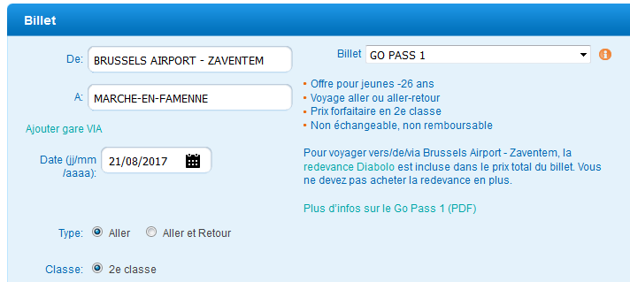

There is also a “Go Pass 10” which offers 10 journeys in Belgium for 52 € and "Rail-Pass" (for people above 26 y.o.) with 10 journeys for 77 €. Both offers are very interesting if you plan to travel in Belgium after the project (to compare, a single ticket between Brussels and Marche costs 15€). Just be aware that the Go and Rail Passes cannot be used from and to Brussels-airport (it is limited to Brussels city stations). **Just be aware: if you buy “Go Pass 10” or “Rail Pass”, you have to pay an additional tax when you travel from/to Brussels Airport only. You need to buy a “Diabolo surcharge”. Ask someone at the main desk.**

**Confirmation slip**

Don’t forget to send us back the confirmation slip in order to give us all the necessary information about your arrival and departure.

**Compagnons Bâtisseurs Belgium - contact person: Michele CURTO**

9 Place Du Roi Albert, 6900 Marche-en-Famenne, BELGIUM

Tel: +32 (0)84 31 44 13

E-mail: [animation@compagnonsbatisseurs.be](mailto:animation@compagnonsbatisseurs.be)

Website: [www.compagnonsbatisseurs.be](http://www.compagnonsbatisseurs.be)

Office opened from Monday to Friday, from 9 am to 5 pm (Belgian time).

**Camp address**

Complexe Saint-François

Rue Victor Libert, 36

6900 Marche-en-Famenne

Belgium

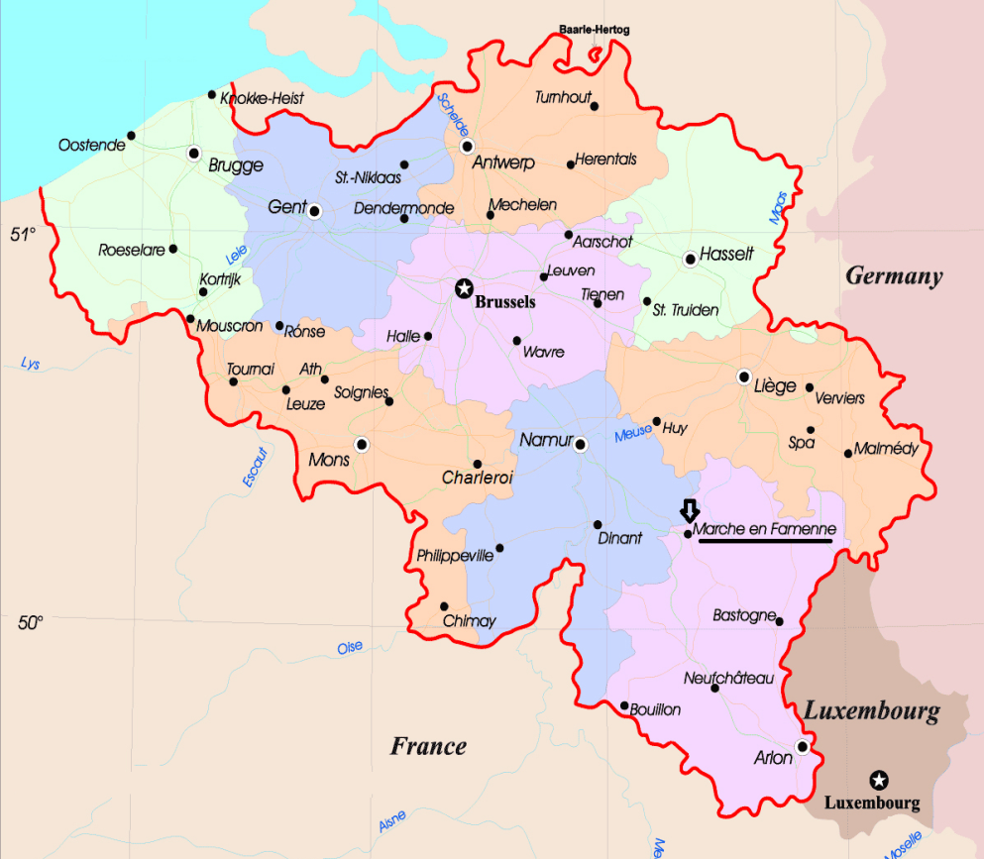



**About the project:**

In 2016, CBB has considered the theme of migratory crisis and integration of refugees as a priority in its activity program. We have developed this through different kinds of activities as well at local as international levels.

At the beginning of this year were published the outcomes of the inquiry « Noir, Jaune, Blues » and the results agreed to say that the discharge of to live together and the fear of the other were very anchored in our current society.

Basis of this report we built the Mosaïc of Diversity project. This one aims at approaching the situation of the integration of the immigrants on the local community where they live and to identify brakes and levers which influence the integration.

This reflection will be translated into a **big fresco realized by the group** according to the aspiration and the ideas of the participants. **They will use various creative techniques such as the painting, the graffiti, the collage, etc.**

The participants will live various types of activities to discover the organized actions and try to deconstruct messages of hatred conveyed with regard to the situation of the migrants in Europe.

Concretely, the participants will have the opportunity to participate in an on-the-spot, to meet various speakers and young people stemming from the immigration and to take part in artistic workshops to realize **big mosaic on the diversity**, which will be exposed in Marche-en-Famenne.

The realized fresco will carry a collective message which will synthesize the look that the group has about the challenge of the inclusion of the immigrants and the factors which can make it difficult to realize. It is also since this fresco highlights tracks of concrete actions which must be able to work in a strengthening of the living together and in a demolition of often firm prejudices.

On October 07th the participants will have the opportunity to participate and to make a presentation of their project to the participants of the annual day of the Compagnons Bâtisseurs which usually gathers hundred people.

This presentation will aim to be interactive and will give great emphasis to the exchange and to the dialogue between the group of participants and the public.

**COMPETENCES AND LEARNINGS OUTCOMES TACKLED BY THE EXCHANGE?**

Young people will learn how to develop and defend their personal point of view, and also respect opinions of other people. This aspect for us looks most important because it’s connected with refugee’s integration.

This program entails the development of leadership skills through fulfillment of common tasks, and sharing responsibilities.

Participants will develop intercultural skills: to value diversity, to ignore stereotypes, and to understand that migration is a normal world process.

**EXPECTATIONS TOWARDS THE PARTICIPANTS?**

* By signing in for this project, we ask you to:
* Be prepared to empower your imagination and to explore your creative skills
* Be ready for an artistic project.
* Be ready to share a rich international group life, to share your culture, your personality and to learn from the other participants’ culture and personality.
* To be prepared to live an experience where they will be responsible of the different aspects of the project: food, tidiness of the place, shopping…

**About the participants:**

We will be 2 groups from 4 (between 16 y.o. and 25 y.o.) + 1 or 2 leaders per group.

|  |  |  |
| --- | --- | --- |
| **Organisation** | **Maximum number of participants** | **Number of group leaders** |
| CBB – Belgium | 4 | 2 |
| Lunaria - Italy | 4 | 1 |

**About the travel reimbursement:**

The travel costs of the participants will be partially or entirely covered, depending of the amount you paid. The contribution to the travel cost is calculated according to the distance between the place of origin of the group (location of the sending organization) and the venue.

The travel of the participants will be **partially covered until 70 % of the travel costs with a maximum of 200€ per participant.**

**It is up to each group to decide of their route. Any public transport and flight company can be used.**

**IT IS VERY IMPORTANT THAT YOU KEEP ALL YOUR TICKETS AND BOARDING PASSES.**

**DON’T FORGET TO KEEP THEM AND SEND THEM BACK TO US AFTER THE PROJECT.**

The costs will be reimbursed by bank transfer to the partner organization, once we have received all your evidences of expenditure.

**About the location:**

Marche-en-Famenne is a small town in the countryside. We can find everything there: schools, supermarkets, industries still … But, it is surrounded by woods, fields and small villages where the life rhythm remains rural. Liège, Namur, Brussels and Luxembourg can easily be reached by train. For more information see : <http://www.maisontourisme.nassogne.marche.be>

**About the accommodation:**

**In Marche-en-Famenne:**

In a former boarding school. The participants will share double or triple bedrooms; toilets and showers are at the same floor. Food facilities will be organised as self-catering. Bring your recipes and enjoy “the kitchen life” !

**About the language:**

During the youth exchange, the official language is English. Other languages should be used for translation.

**What to bring with you?**

* **A sleeping bag**
* **Bed linen**
* **A pillow if you want one (and a pillowcase)**
* **Meds for common diseases** (as flue, sore throat, stomach problems…)
* **travel insurance card and (if applicable) the European health card**
* **Your ID documents and, if you’re under 18 y.o., your parental authorization**
* **Warm clothes and a warm raincoat**
* Ideas for games and activities
* Musical instruments if you play any
* Pictures of your country, your town or your family
* Your good mood and motivation

**What national groups have to bring / prepare before youth exchange**

* to collect and bring with you, articles, posters, flyers, stickers written in you national language and regarding the theme of the project (stereotypes against foreigners and refugees, awareness raising campaign, integration …). It will be useful for artistic workshops.
* to prepare culture evening of your country in original way (concert, quest, national dishes and other)
* to prepare several energizers (example: <https://www.youtube.com/watch?v=Zjf3qyPX4H8>)
* to post on Facebook page of youth exchange small information about members of your team in a creative way (video, cartoon, infographic, funny photos and other). The page will be created very soon.

**What kind of insurance do you need?**

CBB, the hosting organisation in Belgium, covers the insurance of participants’ third liability and personal accident. **CBB doesn’t insure luggage, glasses, dentures or sickness.**

Make sure that you have been vaccinated against tetanus within the last 10 years.

**What we expect from you?**

We expect you will enjoy your youth exchange; you will have fun, make new friends and enjoy many memorable moments. But that doesn’t only depend on us. **You are the main actor in the success of the project**. That means that **we expect that you will take part in the group life**, accept to integrate yourself in a collective dynamic, share jokes and **help your campmates**.

“Keep on changing the world positively !”

☺

**GENERAL INFORMATION**

**ABOUT CBB**

***Compagnons Bâtisseurs Belgium is the national organisation that coordinates your youth exchange in Belgium.***

**Main facts**

The Association des Compagnons Bâtisseurs, aka CBB, is a non-profit, non-political organisation recognized and financially supported as **Youth Organisation** by the Brussels-Wallonia Federation since 1978. It is member of the **ALLIANCE of European Voluntary Service Organisations** since 1997. In Belgium, CBB is member of the federation of the pluralist and independent youth organizations.

As Youth Organisation, CBB is managed by young volunteers. 4 Board members out of 6 and 81% of the members of the general assembly are bellow 35 years old.

**Values, principles and objectives**

CBB recognizes itself in a value of **active pluralism**. The participation in our projects always leave the participants free to make their own choice and decision concerning their personal, cultural, political or philosophical orientation and involvements so far that these orientation and involvements respect the personal situation and the dignity of any other members of the society and respect the core-values of the Universal Declaration on Human Rights.

All the action of the organization is based on the principles of non-formal education (in the French meaning of **Popular Education**). **Our projects** aim to support the development of active citizens, able of sense of responsibility, criticism and solidarity. They offer a **space for interaction and expression** of people from diverse origins and abilities, with the objectives to encourage their awareness on societal challenges (from local to global level), to raise new links of solidarity between them and between their communities, and to support their full participation in the society.

In that sense, any project or activity in CBB encourages:

* **The empowerment of free, autonomous and responsible individuals**. Our projects encourage processes of **social and cultural emancipation**, which means that they invite their participants to reflect on the place they occupy in the society and on the role they can and they want to assume in it.
* **The meetings beyond the differences**. Our projects encourage the awareness to the richness of human diversity and the creation of new social links.
* **The practices of active citizenship** and the promotion of volunteering: by taking part in our projects, people should experiment new ways of participation and to be encouraged to take responsibility in their communities.
* **The informal and non-formal learning processes:** the participation in our projects must permit the acquirement and development of competences such as self-confidence, autonomy, intercultural competences, leading skills, manual, social or linguistics abilities…

**Our programmes and activities**

CBB mainly develops its action with 5 permanent programmes of activities:

* The international workcamps (short term volunteering projects in international group)
* The week-end workcamps (volunteering projects for local groups during the week-end)
* The mid and long term volunteer projects, which include European Voluntary Services.
* The leisure time activities (of one evening, one day, one week-end, one week…) for mixed groups of volunteers and people in situation of disability which are oriented on the meeting and collective action of these people with different abilities.
* The leaders trainings (for volunteer projects and also for kids camps)

**Our public and human resources**

Our activities are developed thanks to a network of 300 members, 150 international volunteers during the summer and a team of 9 employees.

We are a Youth Organisation and most of our public is aged between 16 and 25 years, even if there is not upper age limit to integrate our groups of volunteers.

Our public is diverse. Around 30 nationalities are yearly represented in our projects.

We also implement strategies to facilitate the participation of people from disadvantaged economic and social background as well as of people in situation of disability.

**ABOUT BELGIUM**

**What a tourist guide says:**

*“A rich and bubbling vat of beer, chocolate, oil paint and bureaucrats, Belgium gives off the heady pong of the bourgeoisie. But stir the pot a little and you'll find an 'artificial state' roughly made up of two parts Germanic Fleming's to one part Celtic-Latin Walloons. Divided by pride first and language second, the country's binding agents are a pervasive sense of family and an indomitable entrepreneurial spirit. And if Belgium's spotlight on the European stage is a little dim, it's only because its people are rarely boastful. This country has more history, art, food and architecture per square centimetre than many of its bigger and louder neighbours.”*

(<http://www.lonelyplanet.com/belgium>)

**Full country name:** Kingdom of Belgium

**Capital city:** Brussels (pop: 980,000)

**Area:** 30.278 sq km

**Population:** 10.5 million

**People:** 55 % Flemish (Teutonic origin), 33 % Walloons (French Latin) and about 10 % foreigners

**Language:** Flemish, French and German.

**Government:** Constitutional parliamentary monarchy

**Member of EU:** Yes

**Euro zone participant:** Yes (The currency is €.)

**Facts for travellers**

**Visas:** EU citizens can enter with an official identity card. Travellers from Australia, Canada, New Zealand, Japan, the USA and many other countries need only a valid passport (no visa requirements). To be sure what kind of document you need, check <http://diplomatie.belgium.be/en/>.

**Time:** GMT/UTC +1 (+2 in summer)

**Weights & measures:** Metric

**Electricity:** 220V, 50Hz

**Health risks:** None, except the costs of medical care.

**Transport**

Getting to Belgium: if you are already in Europe, you should consider a bus or a train as your first option (as they are more environmentally-friendly than the plane). Eurolines (<http://www.eurolines.com/>) operate international bus services to and from Belgium and the Belgian Railway Company ([www.b-rail.be](http://www.b-rail.be/)) has also frequent international services.

However, the main international airport is Zaventem (Brussels National Airport), 14 km north-east of Brussels. Depending on when you leave, flights can be cheaper with low cost companies. In this case you will land at Brussels-Charleroi airport, 60 km south-west from Brussels.

Two companies operate car/passenger ferries to and from Britain: P&O Ferries (overnight from Zeebrugge to Hull) and Oostende Lines/Sally Ferries (six boats daily between Oostende and Ramsgate).

Getting around Belgium is cheap and easy - the transport system is dominated by efficient rail network. The fastest services are the InterCity trains, backed up by InterRegional and local trains. If you're under 26 YO, ask for a "Go-Pass", which offers 10 journeys in Belgium for 51 €. If you're older than 26 YO, ask for a "Rail-Pass" (10 journeys cost 76 €). Brussels has three main stations and forms the central hub, with lines in all directions.

In the more remote areas, buses take up the slack. There's a good public transport system (including trams and a small metro system in Brussels and Antwerp). Cycling is popular in the flat north and many roads have separate lanes for bikes.

**Money & Costs**

Banks are the best place to change your money. All major credit cards are widely accepted. Tipping isn't obligatory, and haggling is not used.

**Environment**

Squeezed between the Netherlands, Germany, Luxembourg and France, Belgium is one of Europe's small countries. The north is flat, the south dominated by the picturesque Ardennes and the 65 km North Sea coastline monopolized by resorts, except for a few patches of windswept dunes. Lower Belgium is crossed by a network of canals. Seasons are mild, but the warmest months (July and August) are also the wettest.

**More information at**

<http://www.visitbelgium.com/>

<http://www.trabel.com/>

<http://wikitravel.org/en/Main_Page>

***We look forward to meeting you on the project.***

***Have a great time in beautiful Belgium!***

***CBB team and leaders***

This visual was designed after the evaluation of previous years CBB projects. In several cases, we noticed difficulties in group dynamics because of an excessive use of Internet during leisure times or because of excessive consummation of alcohol in the group life. That is why, on behalf of CBB General Assembly, a working group composed of staff and volunteers prepared these posters, with one recommendation : “*Stay connected with your group and have fun all together!*”.

