Erasmus+ Programme

Key Action 1 - Learning Mobility of Individuals
Mobility project for young people and youth workers

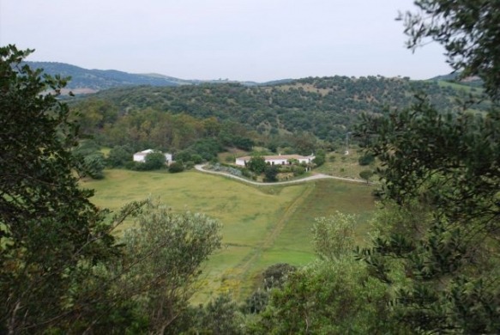
APPLICATION FORM

ReCreAction!
Social Inclusion through Leisure, Creativity and Diverse-Abilities

5th-10th June 2017
(Arrival: 4th June; Departure: 11th June)
Cooperativa “Tierra y Libertad”, El Bosque, Cadiz, Andalucia, SPAIN

Please return this form before Tuesday 2nd May 2017 to: morgaine.equa@hotmail.com

ORGANIZATION:

FIRST NAME:

SURNAME:

GENDER: □ Male □ Female

DATE OF BIRTH:

PLACE OF BIRTH (town, country):

ADDRESS OF RESIDENCE (street, town, country):

TELEPHONE:

E-MAIL:

EMERGENCY CONTACT:

Name: Surname: Telephone:

SPECIAL NEEDS (OR HEALTH REMARKS):

PAST EXPERIENCES:

WHAT IS YOUR MOTIVATION TO TAKE PART IN THIS PROJECT?:

WHAT ARE YOUR EXPECTATIONS OF THE TRAINING?:

