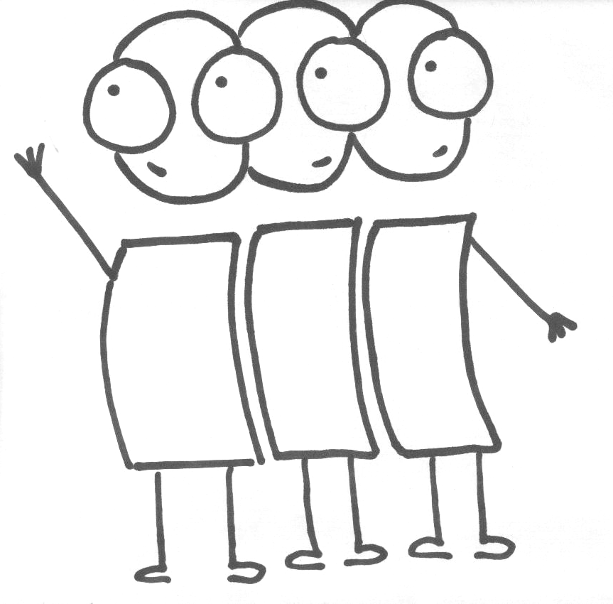
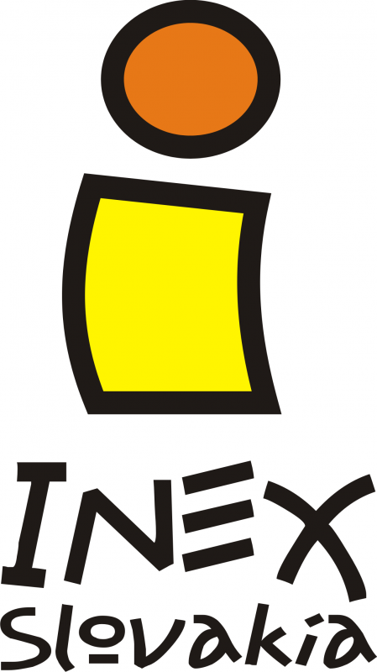 2012-SK-28: “Open your eyes“

Deadline for your application: 15.11.2013

Dates of the project: February 2014 – December 2014

How to apply: send your motivation letter, CV and questionnaire to evs@inex.sk till 15.11.2013

Place of the project:

The project will be realized in our office in Bratislava. The volunteer will visit another parts of Slovakia during the project too depends on our activities as trainings, workcamps, and others events.

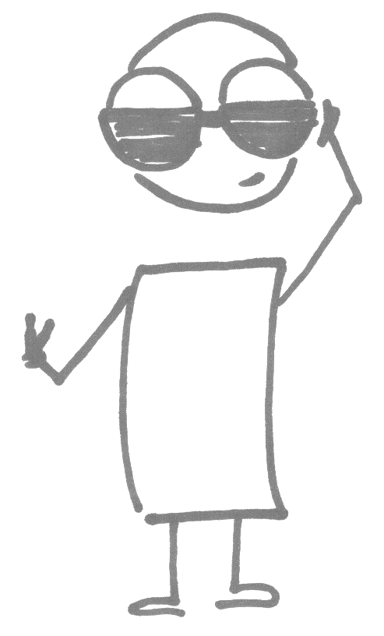
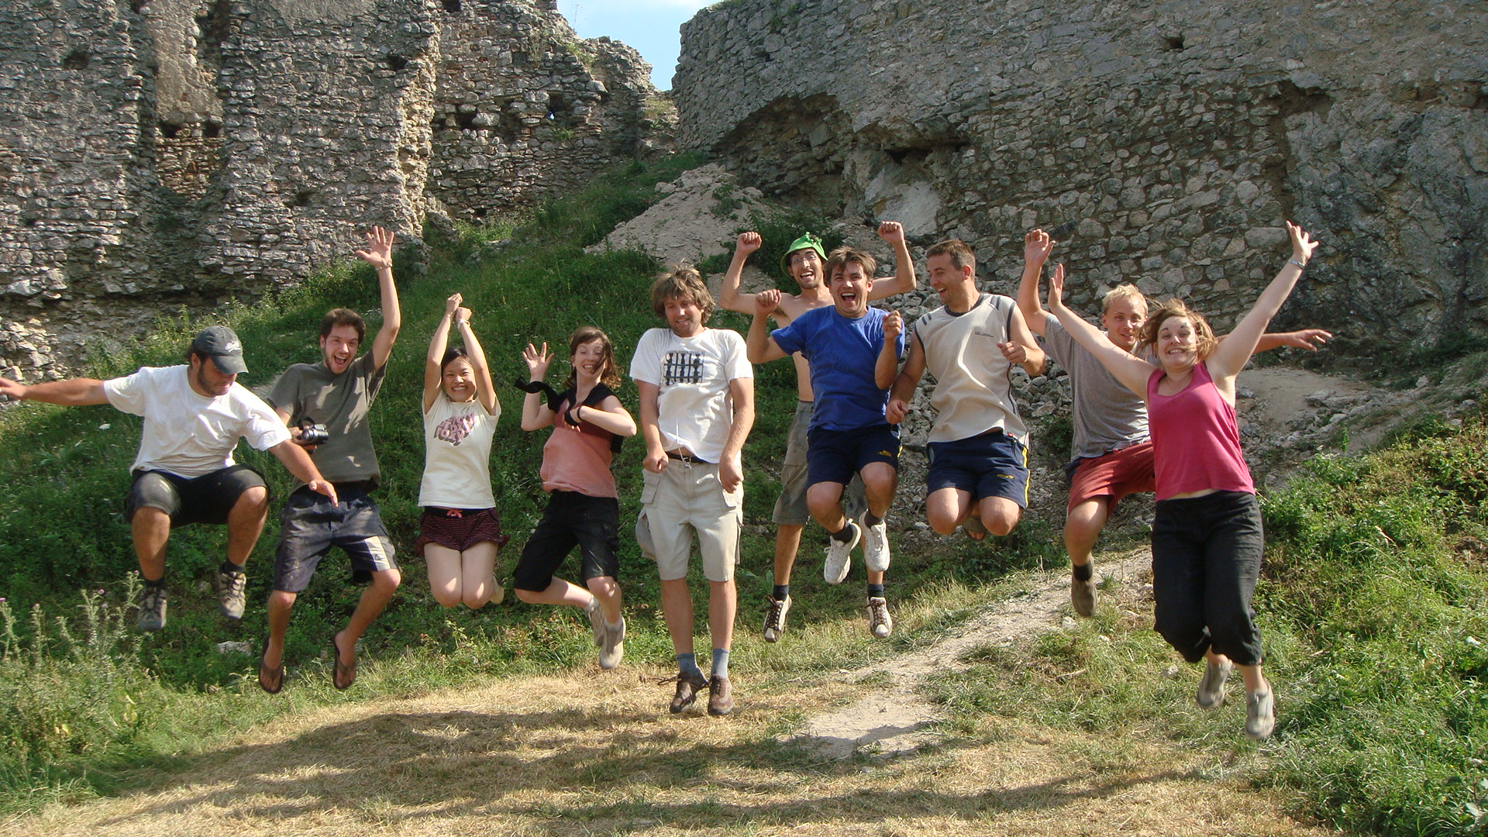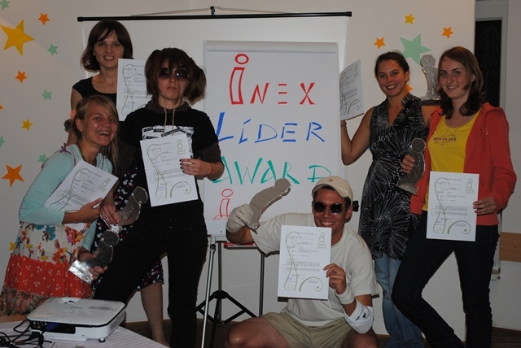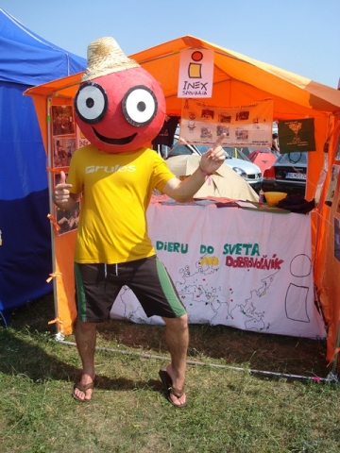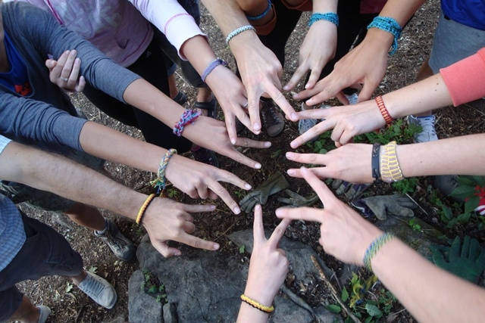

Who are we looking for?

Our criteria are very open. However, the project is focused on working with youth. We would be very happy to host the volunteer with some communication skills and interests in this topic (volunteering, leisure time of youth, workcamps). It would be helpful if the volunteer has some knowledge about theme of our project and would be motivated in working with youth and about international workcamps which are our main activities. Of course we require no drugs use to protect our young volunteers. We would be happy if the volunteer will be interested in Slovakia, its people and culture and wish to learn Slovak language. He/she could be communicative, open minded, creative and ready to work with young people.
The life at INEX and in Bratislava can be hectic sometimes so we will be glad if volunteers will be flexible and independent (in the case of their free time ☺).
The main criteria are the openness and tolerance as INEX is working with young people from around the world.

Main activities of INEX Slovakia

Activities | Description
Organizing Workcamps in Slovakia which take place during summer months | Communication with local partners, with whom we help organizing workcamps during the whole year.  - Preparation of workcamp leaders who are responsible for the nonproblematic running of the workcamp  - Receiving volunteers from abroad who want to participate on our workcamps
International Voluntary Work Camps (high season is during summer months) | Workcamps are short-term international volunteer projects organized all over the world, focused mainly on young people from the age of 18.  Although, every year several teenage camps are organized giving a great opportunity for teenagers willing to join a workcamp. International workcamps enable young people to spend two or three weeks together with 10 – 25 volunteers from different countries and work together on specific project: environmental work, reconstructions of historical buildings, renovations of youth centers, organizing cultural events and festivals, leisure activities for children or work with disadvantaged, handicapped or elderly people.  Necessary activities connected with workcamps:  - Communication with our partner organizations all over the world  - Promotion of workcamps and its main idea of volunteering  - Communication with Slovak volunteers  - Sending Slovak volunteers abroad
European Voluntary Service  EVS | Sending volunteers to EVS-projects  - Hosting volunteers to EVS-projects  - Coordinating EVS-projects  - Promotion of EVS and Youth in action Programme as such
  Training for Camp Leaders (starting in February, ending in June) | We train motivated volunteers who want to lead a workcamp in Slovakia or abroad on several topics:  - Intercultural learning and understanding  - Communication with local partner, volunteers, camp leaders, organizations…  - Motivation  - Conflict Resolution  - Group Development  - Free-time activities, games…  Out trainings are accredited by Ministry of Education of Slovak Republic
Training of Volunteers (during the whole year) | Besides workcamps, our volunteers can participate on various:  - Youth-exchanges  - Seminars  - Trainings  - Projects  - First timer meeting (for those who go to a workcamp for the 1st  time)  Their topics are various, through different organizations, or National Agencies or with the help of the Youth Programme.
“Tea meetings” (every Monday during the school year) | Once a month we organize “tea meetings” for our volunteers and members held usually in our office. There are always different topics which are discussed. (e.g. presenting a foreign country, culture, workshop…).  For our active volunteers we organize cultural events, in order to get to know people better, to keep in touch and to exchange new ideas
Volunteers' Evaluation Meeting  VEM | We organize a big Volunteers' Evaluation Meeting every year in October, where all Slovak volunteers who went to a workcamp abroad, discuss their experiences from their voluntary work and give us feedback, so that we can improve our work and prepare better for the next season.
Promotion of Voluntary Work | We promote the voluntary work on a local, regional and national level, whenever it is possible.
Organizing events in cooperation with our partner organizations | In cooperation with our Slovak partner organizations (Integra, Ulita, Bol raz jeden clovek) we help them with organising events which are held in these organizations. The activities are usually creating and organising free time activities for children with special needs (disabled, children with disadvantaged social conditions…). We provide our volunteers and some material when possible and our partners provide the place for the activities. We want to continue in these activities and even more in future we would like to cooperate in this field with other partners too.
Publications | Catalogue of Slovak workcamps published in the end of February  - Catalogue of International Workcamps published in the end of March  - Guide for a Workcamp Leader  - Various publications which promote volunteering  - Web-page www.inex.sk


Main activities of the EVS-volunteer
· Taking part on the preparation and realization of our activities which are mostly based
on organizing leisure time activities for young people: We would like to involve the EVS volunteer in various activities which we organize. In the beginning we will introduce our activities to the volunteer and it will be up to him/her in which he/she will get involved. It will be chosen according to his/her abilities and skills. But we would encourage him/her to try to participate on activities on which he/she could develop and learn some new experiences and skills. The volunteer would be involved in the whole process of preparing and realizing of the activity. Of course we will help him/her; we will work in a team. We will always explain him/her our idea of how we will organize the activity and we would welcome his/her initiation and contribution with creative ideas and inputs.
We would like to involve the EVS volunteer especially in these activities:
- "tea meetings"- the EVS volunteer may contribute with ideas for the topics of these "tea meetings"; he/she may create an invitation for our volunteers; prepare the office according to the needs for the individual meeting; preparing the material for the "tea meeting"; also we would be very happy when he/she would present his/her own country, culture and ideas.

- Trainings for our volunteers- due to her/his abilities, experiences and skills we would welcome her/his participation on our trainings which we organize for our future camp leaders; on these trainings he/she may do a study session on the topics like intercultural activities or motivation, first aid…; the EVS volunteer may help us as well as a support with organization of these activities like buying material, preparation of the programme… We would welcome creativity and initiation of the volunteer.
- Organizing events in cooperation with our partner organizations- the volunteer may communicate with our partners and create the programme for the activities; prepare and help to realize the activity; promote the activity among our volunteers and motivate them to participate on this activity
- Promotion of voluntary work and EVS; organizing Volunteers´ Evaluation Meeting and other.

· Creating his/her own project: In our project there is a space for the volunteer to create his/her own project of youth exchange financed by Youth in Action Programme. He/she may use the skills and experiences that he/she has learnt already about volunteering and youth. Content of the project would be mostly up to the interests, motivation and skills of the volunteer. It may be promoting of voluntary service or organizing free time activities for young people. The volunteer would be supported and advised on every step. We will also help him/her to evaluate the project so he/she can learn something from it.

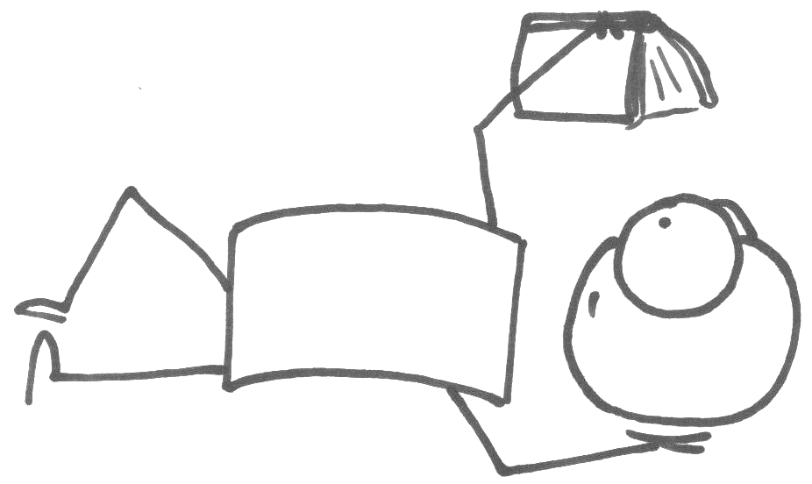
· Administrative work: We would like the EVS volunteer to help us with some administrative work like sorting documents, copying documents and others. The volunteer could communicate with our volunteers, inform them about our activities. The communication will be through mails, phone calls and directly when the volunteers will visit us in the office. The activities will be flexible and will depend on the phase of the project. We will create a timetable for each individual volunteer due to his/her skills, abilities and wishes. In case we organize the project and the volunteer is involved in, she/he is welcome to join the whole project and to help to run the activities. In case the amount of working hours is higher than usually, the volunteer will get alternative holidays. The volunteer will be working in a team.

Practical arrangements
Board
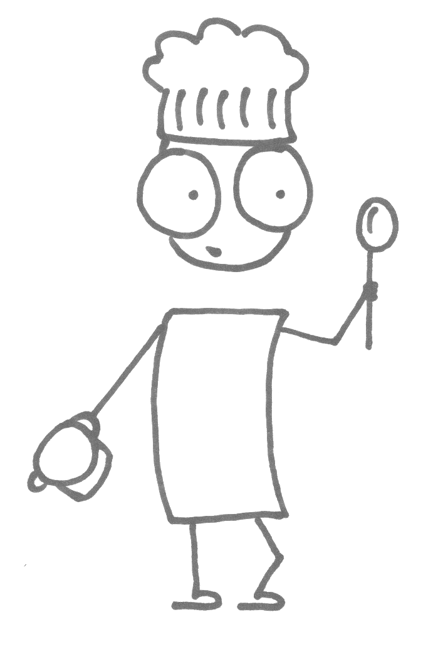
The EVS-volunteers will receive money for food together with the pocket money at the beginning of month. They will manage money on their own, and from these finances they will also buy their food. They will prepare food by themselves. In the flat, where they will be living, there is a kitchen, which they will be able to use.

Accommodation
The EVS-volunteers will be living in an appropriately equipped flat. In the flat there are sanitary facilities and a kitchen. The volunteers will live near the city centre in a rented flat. The accommodation will be of course managed by agreement with volunteers.
Language course
The EVS-volunteers will learn Slovak language at State language school. Slovak language belongs to Slavic languages and it is really beautiful.

Holidays
Volunteers will have holidays during the project which could be used by them how they want after agreement with supervisor. They could have 2 days each month for holidays. So in the case of 11-months project it will be 22 days of holiday.

Traveling in Bratislava
Volunteers will use public transport in Bratislava. They will arrange the card for public transport together with their mentor. Mentor will also help them with orientation in the public transportation system.

For more information you can see:

www.inex.sk

If you have any further question do not hesitate to contact us:
INEX Slovakia
Palarikova 25
821 09 Bratislava
Slovak Republic

Tel. +421 905 501 078
evs@inex.sk

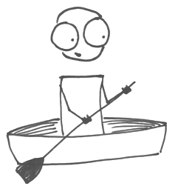

Please send your motivation letter, CV and questionnaire to evs@inex.sk till 15.11.2013

