Youth Exchange

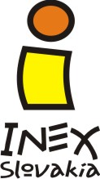
Voluntary Marathon

THEME: The project is aimed at the European Year of Volunteering 2011. It plans to promote volunteering and motivate people to participate in voluntary works in their own regions. It will also show the participants the basics of project management and its use in their home countries. The participants will have the opportunity to present diverse perceptions of voluntary work in their respective cultures. We aim to help with the voluntary work in Banska Stiavnica and at the hand of it motivate other people. During the project we will prepare an informational and promotional kiosk to present volunteering, our project as well as other projects organised by INEX Slovakia. In the end of the exchange we will create some video and photo documentation that will be used for promotional purposes all around Slovakia.

METHODS: The working methods will include interactive workshops, brainstorming sessions, outdoor games, discussions, presentations, debates, role playing games, exercises, energizers, etc. Together with our partners we will try to make the workshops and activities interesting for the participants.

DATE OF THE YOUTH EXCHANGE: 3–13 September 2011 (arrival and departure date)

DATE OF APV: 3 – 5 July 2011

NUMBER OF VOLUNTEERS:
- 4 volunteers (between 18 and 25 years old)
- 1 team leaders (no age limit for team leaders )

WORK:
- Work on the Calvary and on the other places in Banska Stiavnica
- Promotion kiosk about volunteering – participant will prepare promotion kiosk about volunteering and will make promotion in Banska Stiavnica
- Project management – participants will plan their own projects in their country
- Theory of games – participants will get to know more about the using of the games on the projects

LOCATION OF THE YOUTH EXCHANGE: BANSKA STIAVNICA, SLOVAKIA
The project will be organized in the old mining town in the middle of Slovakia. The town is under UNESCO protection with a lot of tourists during the summer. There is a lot of interesting places to visit and also beautiful nature around. The Banska Stiavnica is famous for its old mining history and a lot of lakes and mines.
There are several festivals and events organized in the town during the summer.

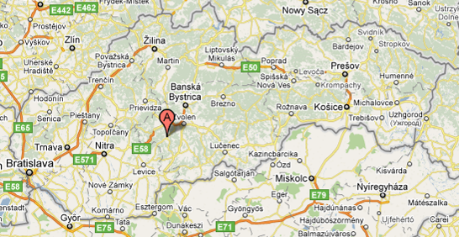

The accommodation is situated in the old centre of Banska Stiavnica. The work place is upon the town at the areal of Calvary. The volunteers need to walk there for app. 30 min.
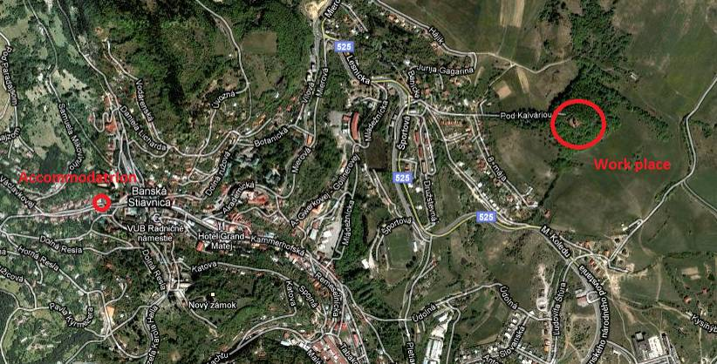
LODGING:
The volunteers will be accommodated in the Scout House, 2.5 km away from the Calvary. Sleeping bags are needed. The volunteers will sleep on the place called “airport”. There are shared showers and bathrooms (two of them for girls, and two for boys). It is a house situated in the centre of Banska Stiavnica. There is also internet connection (1 PC) and a place where you can do your laundry. The Scout house has got very nice garden right under the Old Castle.
For more information: www.skautskydom.sk
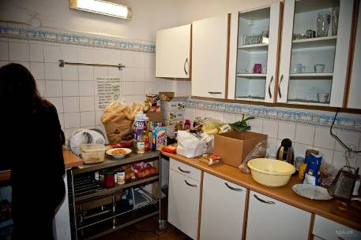
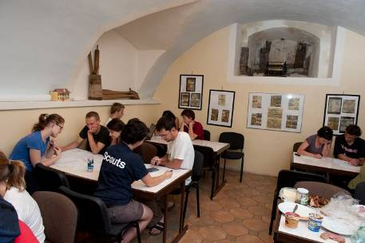
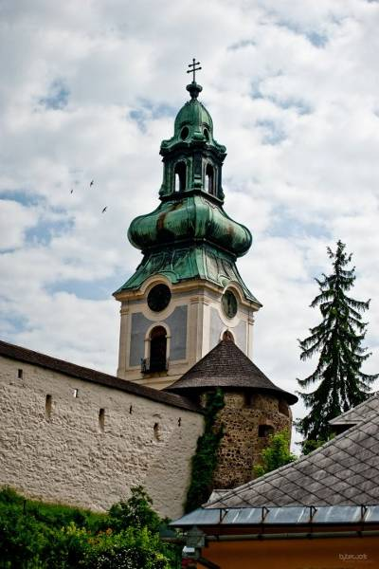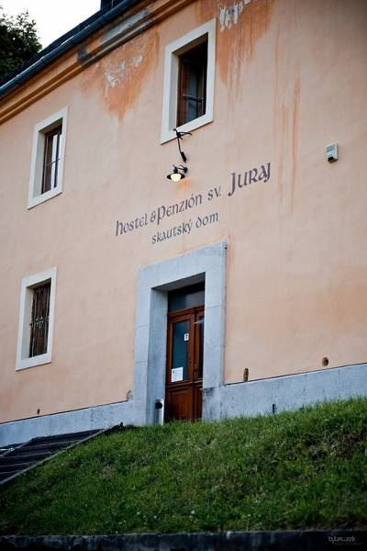

FOOD: During the youth exchange we are going to cook ourselves. We will have 4 intercultural evenings so please bring some of your special recipes and some of your typical food or drink for your National Evening. We are looking forward to meeting your culture and your special meals.

What do we need you to do?
- Recruit motivated volunteers ( participants need to fill out short online application before the project ☺ ) https://spreadsheets.google.com/viewform?hl=en&formkey=dFRkRzlGX3VmZVVDRUxVZGNpcUh1dVE6MQ#gid=0
- Ask your participating group to think about some basic concepts of the promotion materials, kiosk … that we will create and to be prepared to share and integrate them with ideas of other groups.

ACTIVITIES
- advance planning visit (APV): 3. – 5. July 2011, Bratislava/Banska Stiavnica, Slovakia (1 team leader from each country)
  - Finalizing aims and program of youth exchange
  - Discussing practical, logistical and financial issues

Program of the APV:
- Friday: leaders will meet in Bratislava, getting to know each other, speak about expectations also fears and their responsibilities during the project, staying one night in Bratislava
- Saturday: trip to the place of the exchange Banska Stiavnica, planning of the program, staying one night in Banska Stiavnica
- Sunday: trip back to Bratislava, recapitulation of the program, division of the tasks of each leader, travelling home

- selection of exchange participants: June – August 2011 ( deadline – August 13 )
  - 4 participants (between 18 and 25 years old) + 1 team leader from each country (no age limit for team leader).
  - The participants need to fill short online application on:
https://spreadsheets.google.com/viewform?hl=en&formkey=dFRkRzlGX3VmZVVDRUxVZGNpcUh1dVE6MQ#gid=0

- preparation for youth exchange: August - September, 2011
  - meeting of the national groups at their home countries and preparation of materials, ideas ... for promotion, promotional kiosk, ...
  - at least one sessions in each country to:
- introduce the project & all its components to participants
- prepare some workshops for the youth exchange
- discuss logistical issues (travel details, insurance, finances etc.)

- youth exchange: 03.09. – 13.09.2011, Banska Stiavnica, Slovakia ( 4 participants + 1 team leader)
  - non-formal learning through interactive workshops, presentations, discussions
  - working ( 4 hours per day ) on Calvary and other places in Banska Stiavnica
  - promotional kiosk, promotion and communicational materials
  - project management
  - publication about the project

PARTNERS
- INEX Slovakia, Slovakia – hosting organisation
- Concordia France
- ESTYES Estonia
- Lunaria Italy

INEX Slovakia, www.inex.sk

INEX Slovakia is a non-profit, non-governmental organization founded in 1993. Its main aim is to play an active role within the international youth exchange that promotes international understanding, intercultural learning and tolerance.

INEX Slovakia organizes activities that are focused on youth mobility and non-formal education and international volunteering. We organize different voluntary activities like international voluntary workcamps, trainings, seminars, various activities on national level, regular meetings of non-formal groups, workshops, activities for children with difficult background etc. We are a sending and hosting organization within European Voluntary Service. These activities provide an opportunity for young people of different national and cultural background to live and work together; facilitate personal growth and a personal responsibility.

Financial aspects:
APV:
- full room and board covered
- 100% refund of travel costs

Maximum of the travel reimbursement for leaders:
ESTYES | 600 €
Concordia France | 600 €
Lunaria Italy | 500 €

PLEASE BRING ALL TICKETS AND INVOICES SO THAT WE CAN REFUND YOU VIA BANK TRANSFER!

YOUTH EXCHANGE:
- full room and board
- 70% refund of all travel cost for the exchange

Maximum of the travel reimbursement for 1 participant::
ESTYES | 420 €
Concordia France | 420 €
Lunaria Italy | 350 €

PLEASE BRING ALL TICKETS AND INVOICES SO THAT WE CAN REFUND YOU VIA BANK TRANSFER!

