Infosheet
ENJOY YOUR MEAL

Training course, Key Action 1: Mobility project for young people and youth workers
From Monday 21st of September to Tuesday 29th of September
Beginning of the study session: Tuesday 22nd
End of the study session: Monday 28th
Manoir de La Grée, 44660 Soulvache
BACKGROUND OF THE PROJECT
Objectives of the project:
Share and Create tools linked to food in aim to:
- Transform the mealtime in a fun and friendly time;
- Encourage teambuilding;
- Raise environmental and waste awareness;
- Open up to cultural differences;
- Allow youth workers to experiment new techniques, questioning their practices and learn how to adapt to different publics;
- Promote environmental awareness in our partners associations and future projects;
- Strengthen skills, capacity and knowledge of youth workers.
Activities
-Theorical reflexions on sustainable consumption, interculturality and raising awareness methods;
-Creation of awareness tools and implementation on children and youngsters
-Tour of innovative projects;
-Exchange time on good practices and methodologies of participants and their organizations.

Training results
-Improvement of professional practices in the field of environmental and intercultural awareness for associations target group;
-Creation of a network of European youth workers multipliers;
-Open minds of the trainees;
-Create a Tool book for meal time.
Methodology
We use non formal methods: workshops, small and big mixed groups, manual work, sharing of experience and knowledge, debates, participative evaluations.
Participants are actively involved in all the activities of the project, from preparation to final realization. They will prepare the training at home, they will play an active role during the project and they will go back home with tools to disseminate the final results.

PROFILE OF PARTICIPANTS
Youth Workers or Youth Program Coordinators

FINANCIAL ASPECTS
Concordia would like to encourage participants to buy travel tickets ASAP to enjoy economical prices. Please do not buy travel tickets until your participation has been approved by Concordia. All the travel costs will be reimbursed the earliest 3 months after the end of the training course/youth exchange.
Please note that the process of reimbursement will be carried out directly with the applicant organizations and not with the individual participants. We kindly remind all participants to keep the original tickets.
Association | Country | Participants | Travel costs
Lunaria | Italy | 3 | Up to 275€
Elix | Greece | 3 | Up to 360€
RDC | Belgium | 4 (3 trainee + 1 trainer) | Up to 275€
Deineta | Lithuania | 3 | Up to 360€

ACOMOMODATION
Participants will be accommodated either in tents or dormitories depending on their will. Nights may be cold, so please bring a warm sleeping bag and warm clothes (beds or mattresses are provided).
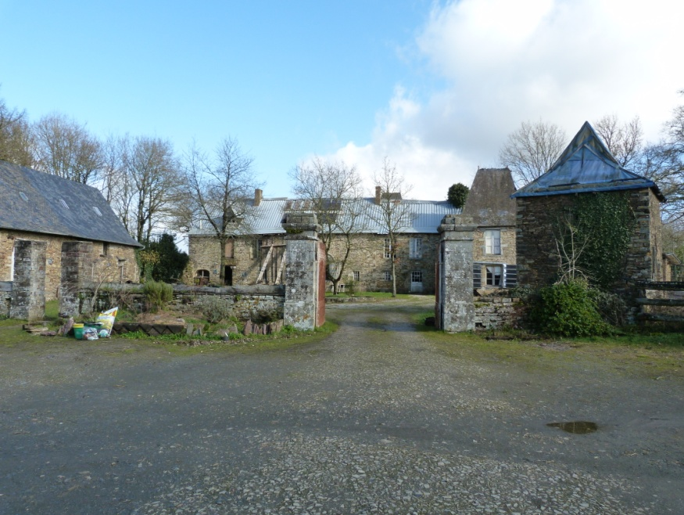
The hosting place is called Manoir de la Grée which develops self-sufficient and sustainable ways of living. Hence there’s only solar electricity, the water comes from the well and the toilets are dry. The shower is solar as well, we kindly ask participants to use it in a responsible and friendly way so everyone will be able to have enough hot water. Be ready to have a live changing and sustainable experience. You'll have 30 hectares of nature to enjoy, the river and the forest to discover, and you will get to know a typical little village of France.
The food will be cooked from organic products from the little producers of the area.

DON’T FORGET TO BRING WITH YOU
- Sleeping bag
- Towel
- Good shoes for rain and mud
- Flash light
- Warm clothes (pant/ sweat/ sock/ raincoat)
- Clothing suitable for outdoor activities (skirt or short/ t-shirt)
- Hat & sunscreen
No need to bring shampoo or shower gel, we will provide home made products as we want to be as much eco-friendly as possible.

We will offer you a place to keep your valuable items, but if they are not essential, please do not bring them.
You are fully responsible for all your belongings.

MEETING POINT
Monday 21st of September
In Chateaubriant Train station (44)

Please write an email to dr.bretagne@concordia.fr to let us know your arrival time. Feel free to contact Yohann, your trainer if you encounter any problems during your journey.
Yohann 0033.(0)6.86.77.78.21

HOW TO GET THERE?
By train/by bus/ by plane
The closest airports are Rennes, Nantes or Paris. From here you can take a train to Chateaubriand. Check out the train timetables at http://uk.voyages-sncf.com/en/.
Some examples:
Trains from Rennes to Chateaubriand at 13:35 or 16:45
Trains from Nantes to Chateaubriand at 12:35 or 16:35 or 17:35

We will pick you up at the train station so please do not forget to send us your arrival time asap.

CONTACT INFORMATION/ EMERGENCY CONTACT
Nolwenn MELCHIOR
dr.bretagne@concordia.fr
+33 6 73 29 75 69

We are looking forward to seeing you!!

