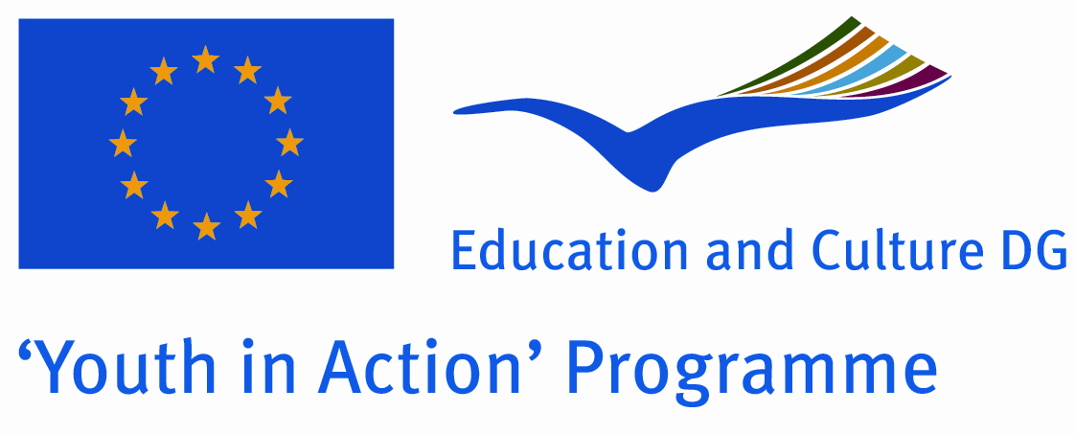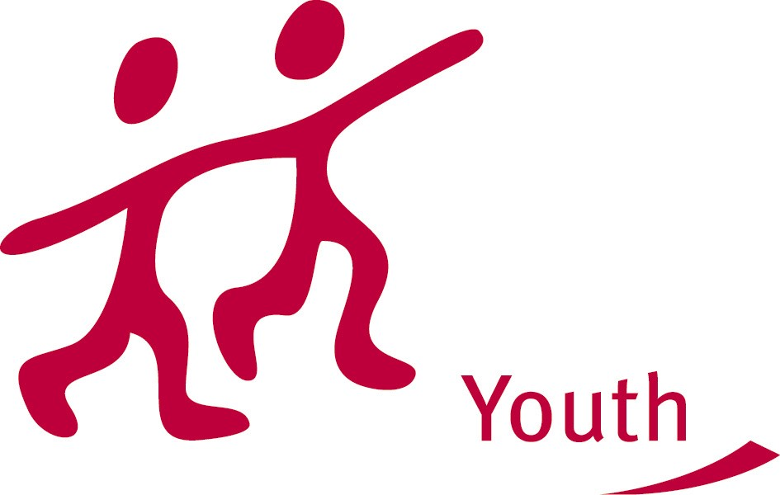

TRAINING COURSE, Action 3.1 “GO TEEN!”

Theme: The aim of this training is to empower participants with new tools and working methods in order to tackle the issues of leading a teenage workcamp. The training also aims to stimulate a reflexion on the challenges of a first mobility for teenagers, on the impact on their active citizenship as well as on their socioprofessional path.

Countries involved: Italy, Germany, Serbia, Ukraine, Armenia and France

Dates: 14/10/2013 (arrival day) - 21/10/2013 (departure day)

Venue : Château de Bellevue, Presles (close to Paris)

SURNAME: |  |  | Firstname:
Phone number: |  |  | Mobile :
Email :
Present adress: |  |  | Permanent adress / Adresse permanente (ex. : Parents) :
STREET |  |  | STREET
STREET |  |  | STREET
ZIP CODE | TOWN |  | ZIP CODE |  | TOWN
STATE - COUNTRY |  |  | STATE - COUNTRY
Gender: |  | Age : |  | Birthdate :
Nationality : |  |  | Birthplace :
Sending organisation:

Why would you like to take part in this training?

What are your expectations about this training?

Can you describe your previous education and your professional experiences and / or voluntary work ?

Where do you see yourself in the future?

Do you have any health problems (e.g. allergies) or handicaps ? Special needs ?

Emergency contact :

NAME : Phone number:

Association CONCORDIA
64 rue Pouchet – 75017 PARIS
FRANCE
Tél. : +33 (1) 45 23 00 23
vlt@concordia.fr

